​​[Company Name]​
Welcome to Siikajoki!
​​[File Subheading]​

The Municipality of Siikajoki
October 7, 2022

​Contents
Foreword…………………………………………………………………………………………………………………………………………..……2Life in Siikajoki……………………………..……………………………………………………………………………..………………….………3
What is Siikajoki?................................................................................................................................3 Services in Siikajoki…………………………………..……………………………………………………………………………………4 Healthcare and Wellbeing……………………………………………………..………………………………………………………6 Attractions in Siikajoki…………………………………………………………………………………………………………………..7
Education……………………………………………………………………………………………………………………………………………….9 The Finnish Education System and Degrees…………………………………………………………………………………..9 Early Childhood Education and Care…………………………………………………….………………………………………10 Preschool Education………………………………………………………………………………………………….…………………11 Basic Education…………………………………………………………………………………..……………………………………….12 Upper Secondary Education…………………………………………………………………………………….………………….13 Higher Education…………………………………………………………………………………………………………………………13 Education for Immigrants…………………………………..……………………………………………………….……….……..15 Adolescents without a Student Place…………………………………………………………………………………………..16
Information about Finland……………………………………………………………………………….………………………………….17 Equality………………………………………………………………………………………………………………………..……………..17 Culture…………………………………………………………………………………………………………………………………………18 Religions……………………………………………………………..……………………………………………………………………….19 The Finnish Nature………………………………………………………………………………………………………………………19
Frequently Asked Questions…………………………………………………………………….………………………………………….22 Education…………………………………………………………………………………………………………………………………….22

Foreword
Hello and Welcome to Siikajoki!
Siikajoki is an idyllic, rural-like municipality. We have a lot of nature and water areas but also active cultural life and opportunities!
This guide is particularly meant for people moving into the country and for their families. The purpose was to create a guide that provided versatile information available in one place. The guide includes concise information on the municipality of Siikajoki and the services it provides. It also has summarized general information on Finland and on being a Finn.
For easier access to information, this guide also includes some necessary websites and telephone numbers for contact people.

Life in Siikajoki

What is Siikajoki?

Siikajoki is a long municipality that consists of 10 smaller villages. Its largest center is in the village of Ruukki where municipality services are also located. All in all, Siikajoki is a tranquil municipality and very close to nature, where you can really enjoy the quietness.
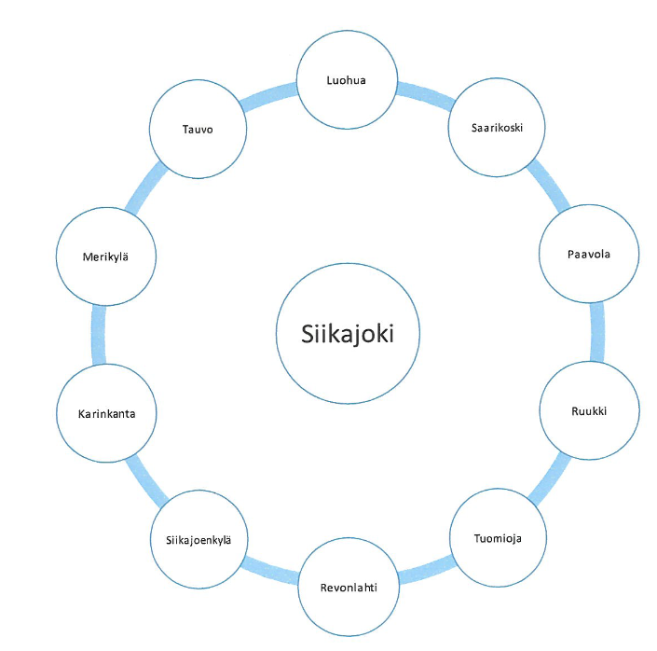

Siikajoki is also conveniently located between two larger cities: Oulu and Raahe. Hence, it’s very easy to travel to those cities. Oulu is about an hour away by car, but the train takes you there in 30 minutes. Raahe is also conveniently 30 minutes away. In addition, the main Ostrobothnia train track runs through the municipality of Siikajoki, which makes it easy to travel to Helsinki, the capital of Finland, or to other cities such as Seinäjoki or Tampere. Oulunsalo airport is about 40 minutes away.

Services in Siikajoki

Siikajoki offers many services to its residents. The municipality center is located in Ruukki, the administrative center of the municipality of Siikajoki. All the main services are situated within 1 kilometer radius from the Ruukki village center.
Services available in Ruukki:
- Health services: health center
- Pharmacy
- Main library
- Parish hall
- Bank
- Grocery store Sale and K-Market
- Flower shop
- Taxi services
- Railway station
- Postal and Matkahuolto services
- Petrol station
- Fire station
- Restaurants
- Pizzeria
- Evening restaurant and a pub

Ruukki is a small village located at a scenic riverside. As a growing environment for children, the village is very safe, international, and communal. Despite its small size, the village is very active and lively. There are many possibilities both in recreational sports and in social opportunities. Ruukki
has village association activity and sports clubs. Recreational facilities include e.g., Kärkiniemi sports field, tennis field, pesäpallo (baseball) field, and a gym. Hietamaa leisure center has a disc golf course, an FK track, and swimming and skiing opportunities.
In addition, there are annual events in Ruukki, such as Finland’s garden fair, and Ruukki’s organic and local food fair. Rural municipality days also take place in the summer. Events organized in the municipality can be found, for example, on the municipality website or the Ruukki village association website.
Ruukki village’s website: http://ruukinkyla.blogspot.com/

So, there are plenty of opportunities to be active, experience things, and grow. In addition, as an old industrial municipality, Ruukki has unique history to offer.

Libraries
The libraries in the municipality of Siikajoki are part of the OUTI libraries in the Oulu region. In all the library units in the Oulu region, you can use a computer, reserve books, and return checked out loans to any library. In Siikajoki, there are libraries in Ruukki, Revonlahti, Paavola, Siikajoenkylä, and Luohua. In addition to books, the libraries have magazines, games, music, and movies.
The libraries also host different types of events and activities. There are occasional story times for children and art exhibits that are open for everyone. In addition, the libraries offer help in using the computers.
You can use the library for browsing or doing research, but also for reading. Most libraries have a reading room which is meant to be a quiet space where you can work in peace.
You can search for books in Finnish and in other languages on the OURI libraries’ website
https://outi.finna.fi/

Healthcare and Wellbeing

The Emergency Number in Finland is 112.
You can call the emergency number if you need help from the authorities in urgent emergencies. The emergency response center answers in Finnish or Swedish. For other languages, they can use an interpretation service, for which the caller must be on hold for a while.

The Welfare District of Raahe is responsible for welfare and wellbeing in the municipality of Siikajoki. It offers social and healthcare services for residents. Health center doctors’ and nurses’ reception can be reached through the following telephone numbers:
Ruukki tel. 08 849 4612
Siikajoenkylä, tel. 08 849 4632

In addition, there is an urgent care service in the municipality of Siikajoki, for which the telephone numbers are:
General urgent care
Tel. 116117

Dental urgent care
Ruukki dental clinic (8 AM to 3 PM from Mon to Thu, 8 AM to 2 PM on Fri)
08 849 4728

Attractions in Siikajoki

Churches
There are 3 churches in Siikajoki:
- Siikajoki Church, built in 1701
- Revonlahti Church, built in 1775
- Paavola Church, built in 1756
Art by church painter Mikael Toppelius is displayed in the churches.

Meeting and Event Venues
The old parsonage of Siikajoki is a beautiful old building that has a monument of the Finnish War. Revonlahti Home District House, built in 1822, can also be used as a venue for meetings or events.

Paavola Home District Museum and Observatory
Paavola Home District House is located near Paavola Church. It was built in 1847 and displays a variety of artefacts related to local history. The museum is open in the summer on Sundays, and they collect a small entrance fee.
Paavola Observatory was completed in 1989 and renovated in 2011. The observatory is owned by Oulun Arktos (Oulu’s Arktos), and it can be visited by appointment.

Statues and Monuments
- Luohua saarnatupa (Sermon House) Monument, Luohua
- Memorial to the Dead who Remained in Karelia, Paavola
- War Memorial, Paavola
- Siikajoki Battle Memorial, Siikajoenkylä
- Memorial Boulder to the Fallen Soldiers of the Battle of Siikajoki, Siikajoenkylä

- Memorial to the Deceased War Heroes, Siikajoenkylä
- Memorial to the Fallen Soldiers of the Finnish War, Revonlahti
- Vapauden liekki (The Flame of Freedom), Revonlahti
- Memorial to the Deceased War Heroes, Revonlahti
- Paavola Veteran Park, Paavola
- Parkinkiskoja Statue, Siikajoenkylä
- Kivilehmät (Stone Cows), Installation Art by Hannu Ahosola, Ruukki.

Other
The municipality of Siikajoki offers a variety of natural attractions. When exploring natural attractions, the rules and everyman's rights regarding the Finnish nature must be observed. Depending on the attraction, many Finnish natural attractions have guideboards on-sight. When exploring nature, please keep in mind that there may not be any toilets or outhouses available. In addition, you may want to bring a packed meal or at least a water bottle. Otherwise in Finland, hiking and camping is quite unrestricted and safe. More information about this can be found in chapter (?????).
Fishing in water areas is allowed in accordance with the Finnish fishing regulations. You should check the need for fishing permits well beforehand. However, ice fishing and angling are allowed throughout the year and no fisheries management fee is required.
Karhuviiankivi in Luohua is also a wonderful natural attraction. It’s a glacial remain, or a glacial erratic. Karhuviiankivi offers climbing possibilities also for the experienced climber.
The Vekala suspension bridge in Paavola is accessible by foot or by bike. It’s 70 meters long and meant for recreation and exercise. The sandy beach in Tauvo is also a nice recreational spot. Tauvo sand dunes are a great place for swimming or surfing in the summer. It also attracts fishers and birdwatchers. During the summer, there’s also a kiosk open at certain times.
You can explore attractions more closely on the municipality of Siikajoki website:
https://www.siikajoki.fi/nahtavyydet

Education

The Finnish Education System and Degrees
The Finnish education system is one of the best in the world, and schoolteachers are highly educated. The Finnish school system is valued around the world, and Finnish learning results have been very good for years. Basic education is indented for all citizens and it’s mandatory. The goal of education is to provide equal opportunities for all and to guarantee equality. The differences between schools and municipalities are slight, and most schools are public. In addition, pre-primary education, basic education, and upper secondary education are completely free. The school meal is part of the school day, and it’s provided for free by the municipality for all pupils. Pupils’ dietary restrictions and possible allergies are taken into consideration at school meals.
The purpose of education and teaching is to create a unified and progressive whole that takes into consideration the factors that affect the pupils’ learning, such as their age, cultural background, and other special features. The education system, as a whole, consists of early childhood education and care, preschool education, basic education, upper secondary education, and higher education. In addition, there is a wide variety of education opportunities for adults at different educational levels. There are flexible education paths for people with different language or cultural backgrounds that take into consideration the need for individual support. Together, they help to further acculturation and integration into the Finnish society.

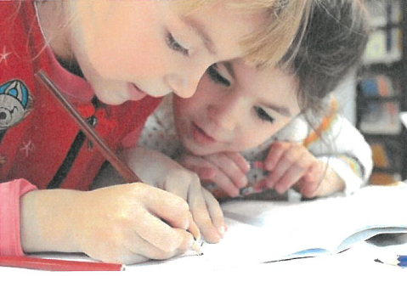

Early Childhood Education and Care
Early childhood education and care is meant for children who haven’t yet reached school age. Early childhood education and care lays the foundations of a child’s wellbeing, development, and study path. The child can participate in early childhood education and care in a day care center or in a family day care. In Finland, municipalities are responsible for organizing early childhood education and care, and it’s more affordable for families. The goal of early childhood education and care, together with the child’s guardians, is to create a solid basis for the child’s overall growth, development, and learning. In early childhood education and care, the child learns important skills and knowledge, and their growth as a person is strengthened. Early childhood education and care is of significant importance to the child’s development as it forms the foundations of their academic success and prevention of social exclusion.
The Act on Early Childhood Education and Care regulates the quality of early childhood education and care, and the National Core Curriculum for Early Childhood Education and Care forms the basis of care and upbringing. Those working with children are trained early childhood education and care teachers, Bachelors of Science in Sociology, and practical nurses.
There are 4 day care centers in the municipality of Siikajoki:
- Tuulenpesä Day Care Center, Siikajoki
- Repola Day Care Center, Revonlahti
- Satumetsä Day Care Center, Ruukki
- Leppis Day Care Center, Paavola

Contact Information
Early childhood education and care manager of the municipality of Siikajoki:
Sari Mällinen
Tel. 040 3156 377
Email: sari.mallineniikajoki.fi

Preschool Education
Preschool education is part of early childhood education, and it’s regulated by the Basic Education Act. In preschool, children learn, for example, social interaction skills, language skills, and develop their readiness for basic education learning through play and activities. There are specific national and municipal goals set for preschool education.
It’s important to take into consideration the children’s language, cultural, world view, and religious backgrounds. Cooperation with the guardians is also important. Together, the early childhood educational staff and the guardians make sure that the child regularly participates in preschool education.
Preschool education starts in August when the school year starts. When possible, children are offered morning and after-school activities. Activities are organized if there are at least 5 children in the group. For enrollment, fill in the application form and return it to the school or the school administration office at the municipal office.
For more information, contact the school administration office at the municipal office
Virastotie 5A
92400 Ruukki
Tel. 040 3156 299

Application form for preschool enrollment:
https://www.siikajoki.fi/sites/siikajoki.fi/files/liitetiedostot/Oppilasilmoitus%20esikouluun%20tulevalle.pdf

Basic Education
Basic education provides pupils with general education and prepares them for being members of the society. The duration of basic education is 9 years, and it makes all pupils eligible for further studies. The criterion for Finnish basic education is to provide quality teaching to all pupils regardless of their prior skills. Basic education is also regulated by the Basic Education Act and the National Curriculum. Basic education is completely free.
There are 5 schools in the municipality of Siikajoki that offer basic education:
- Gumerus School
- Luohua School
- Paavola School
- Revonlahti School
- Ruukki School

Pupils must be enrolled in basic education before starting school.
For more information, please contact the school administration office:
Virastotie 5A
92400 Ruukki
Tel. 040 3156 299

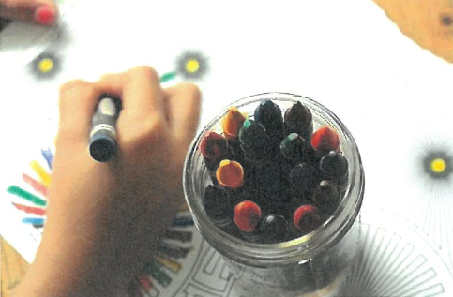

Upper Secondary Education
Upper secondary education ensures meeting cultural and vocational skill goals and the required skills for work life. Finnish compulsory education ends when the pupil reaches the age of 18 or when they complete an upper secondary qualification. Therefore, a pupil ending their basic education must apply for post-comprehensive school education. All educations can be applied for through joint application procedure for which the application period in 2023 is between Feb 21, 2023 and March 21, 2023.
Upper secondary education consists of either general education (lukio) or vocational education and training (ammattikoulu). General education provides students with skills for applying for and starting to study in a higher education institution or in a vocational education and training equivalent to the general education syllabus. Vocational education provides possibilities for over 100 vocations in 8 different educational fields. In addition, it provides skills for attending higher education institutions.
In the municipality of Siikajoki, you can study either in general education (lukio) or Ruukki Rural Institution (maaseutuopisto). There are more vocational schools, for example, in Raahe and Oulu. The teaching language is Finnish. Education options are available at:
https://opintopolku.fi/konfo/fi/

Higher Education
Higher education consists of either university education or universities of applied sciences. The purpose of universities is to produce scientific research and to work in close interaction with the society. Universities of applied sciences answer the challenges of work life through the starting point of research or art. The quality of higher education depends on the institute itself, but the evaluation of education is done by the Finnish Education Evaluation Centre (Karvi).
Both universities and universities of applied sciences award degrees that are either Bachelor's or Master's degrees. The general duration of studies for a Bachelor’s degree is 3 years and 2 years for a Master’s degree. In addition, when applying for a university education, you can apply directly for the right to study for both Bachelor’s and Master’s degrees. Depending on the educational field, the duration of studies for a degree in a university of applied sciences is between 3.5 and 4.5 years.

The requirements for being accepted to study for a Master’s degree are: a university of applied sciences degree or other applicable degree and several years of work experience.
The nearest university to the municipality of Siikajoki is the University of Oulu in Oulu. Also, the campuses of Oulu University of Applied Sciences are located in Oulu and Oulainen, about 65 kilometers from Siikajoki.
The Summer University of Northern Ostrobothnia (Pohjois-Pohjanmaan kesäyliopisto) in Raahe offers mainly open university education. The Raahe unit also offers vocational continuing education, university activities as well as events for the general public.
For more information, please contact the Raahe unit or visit the Summer University website:
https://www.ppkyo.fi/
Rantakatu 5D (1st floor), 92100 Raahe
Open: 9 AM to 3 PM, Tue to Thu. Other times only by appointment.
Tel. 044 439 3301
email: kesayo(a)raahe.fi
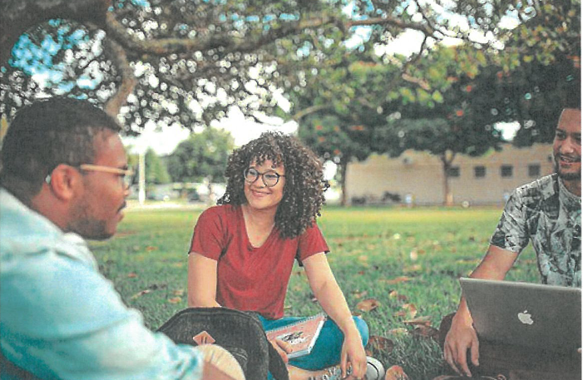

Education for Immigrants
Regardless of their level of education, all immigrants coming to Finland are offered Finnish or Swedish teaching, including lessons in reading and writing.
The goal of preparatory education for basic education is to support the pupil’s multilingualism and to guide their balanced development to build their multicultural identity. A Finnish Permit of Residency is not a requirement for participating in preparatory education. Preparatory education for basic education is organized for children and adolescents whose age is equal to the age of pupils in preschool education or in basic education and lack sufficient linguistic skills to receive preschool education or basic education.
The duration of preparatory education is usually 1 school year. For children between 6 and 10 years of age, this means approximately 900 hours of teaching and appr. 1000 hours of teaching for children over 10 years of age. During preparatory education for basic education, each pupil received their personal study plan where the preparatory education teacher, together with the guardian and the pupil, writes down the educational goals, subjects to be studied, and possible measures of support. Cooperation with the guardians is considered very important. Therefore, the guardians receive information about the school and the pupil’s studies. The pupil’s own native language is supported, and its usage is regarded positively.

Preparatory education for basic education is organized in Ruukki school throughout the whole year. Preparatory education is intended for pupils with immigrant backgrounds.
For more information, please contact the school administration office:
Virastotie 5A
92400 Ruukki
Tel. 040 3156 299

Adolescents without a Student Place

Outreach Youth Work is intended for all adolescents between 15 and 29 years of age. Youth worker helps adolescents with the exact matters they need help with. Outreach Youth Worker works in Raahe, Siikajoki, and Pyhäjoki areas. They can be reached by the adolescents themselves as well as the parents. You can contact them by telephone, email, or WhatsApp. Siikajoki Outreach Youth Worker is also on social media.

Contact Information for Outreach Youth Worker:
Veera Karppinen
tel. 040 3156 243
veera.karppinen(a)siikajoki.fi

Facebook: Satelliitin Jenna(Veera)
Instagram: Satelliitin_veera
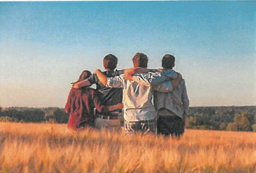
Snapchat: veera_ent
Discord: SatelliitinVeera#5491

Youth Center Ruori
Pekkalantie 11,
92400 Ruukki

Information about Finland
Finland is an independent republic. Finland became independent in 1917, and Independence Day is celebrated on December 6th. Finland is part of the Nordic countries and the European Union. Finland is the most sparsely populated country in the European Union, and in 2022, the population of Finland was appr. 5.53 million people. Most residents live in the Southern parts of the country where the capital of the country, Helsinki, is also located. Over a million people live in the Helsinki Metropolitan area. Åland is an autonomous part of Finland, and its municipalities are self-governed.
There are 2 national languages in Finland: Finnish and Swedish. Approximately 5% of the population speaks Swedish as their mother tongue. The Sámi people live in Finland, as well, and they are the only indigenous people in the European Union. The Finnish basic education includes a large amount of foreign language studies. Hence, the residents speak good English almost in all parts of the country. Towards the end of year 2021, 8.3% of the Finnish population were foreigners (Statistics Finland, 2022). The number of foreigners in Finland has been steadily growing already for decades.
Finland shares a border with Russia, Norway, Sweden, and Estonia.
The currency in Finland is the Euro.
There is a strong freedom of speech as well as freedom of the press. Among newspapers and the radio, Yle, for example, is an independent public service media company that offers news in several different languages.

Equality
In Finland, all people have the same rights, and everyone is to be treated equally. Therefore, people should be treated the same way regardless of their gender. In work life, the Act on Equality between Women and Men guarantees everyone equal possibilities and equality. For example, discrimination is a crime.
In Finland, you are allowed to marry if you want to, and both spouses also have the right to file for divorce. In Finland, same-sex marriage is also allowed.
In Finland, violence in all its forms is a crime. This also includes domestic violence and violence against a partner. Also, children have their own rights, and their opinions are taken into

consideration regarding their own matters. Physical punishment of children is equally forbidden.

Culture
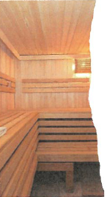
The Finnish culture is largely influenced by the Swedish and Russian cultures, but it has also developed into its own culture. The Finnish folk tradition has been passed down from generation to generation in the form of myths, stories, and fairy tales. However, the Finnish culture and being a Finn is often associated with the Finnish “Sisu” or perseverance, rationality, and introversion. The Finnish people are social, but privacy is valued. Hence, surprise visits and mundane small talk aren’t as popular as in many other countries.
One important cultural trait is related to the Sauna. Indeed, Finland is a country with the most saunas in the world. There are different types of saunas. Many are located in public spaces. The purpose of sauna and going to the sauna is to cleanse yourself and to relax. Throughout history, sauna has believed to have healing powers and, for example, children used to be born in saunas.
Diligence and modesty are also Finnish personality traits. The Finns follow schedules very closely, and being late is to be avoided. For example, if a work meeting starts at half past 8 AM, everyone is expected to be there by 8:30 AM.
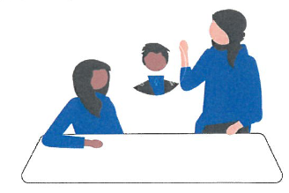

Religions
Finland has freedom of religion which means that everyone living in Finland has the right to choose their own religion and to practice it freely. The most popular religion in Finland is Christianity, with approximately 70% of the population belonging to the Evangelical Lutheran Church of Finland. The Orthodox Church of Finland is the second most popular religion, and its members make up appr. 1% of the population.
In Finland, there is a significant number of members of other religions, such as the Catholic Church in Finland, the Pentecostal Church of Finland, the Evangelical Free Church of Finland, the Adventist Church of Finland, the Church of Jesus Christ of Latter-day Saints in Finland, and Jehovah's Witnesses. There is also a large number of Muslims in Finland.

The Finnish Nature
In Finland, nature is very important to the Finnish people and being a Finn. Hiking in the Finnish nature is mostly safe and doesn’t require any particular actions or equipment. The Finnish nature is definitely an important part of people’s everyday lives. It offers a chance to enjoy a little peace and quiet. In addition, Finnish forests are very clean. However, when exploring forests and nature, you should follow common rules and everyman's rights. For example, making a fire is not allowed everywhere, and you must never litter. Berries, mushrooms, and branches fallen from the trees can be picked freely if they are not on anyone’s property.
For more information about everyman's rights, please visit:
https://www.suomenlatu.fi/vaikuta/jokamiehenoikeudet-2?gclid=CjwKCAjwkaSaBhA4EiwALBgQaJIA0ov9pkkXCrMk62qCDySK_5gGDF6v_2iNnbneQIdrQ3jSppydvxoCu8gQAvD_BwE (Finnish, English, and Swedish)

https://ym.fi/etusivu (Finnish, Swedish, Russian, and English)
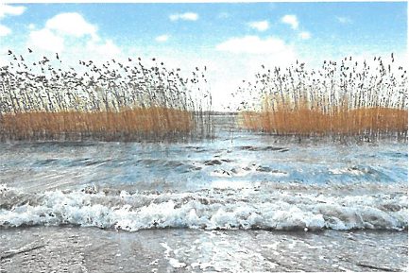

The Finnish nature has inspired several artists, authors, and composers. Many songs and poems are written about it, and its beaty has been admired through the ages. The Finns associate nature with a healing power and an empowering element. Especially water is an element repeatedly present in Finnish artwork and conversation.
The national animal of Finland is the bear, and the national fish is the perch. There are only few dangerous or venomous animals in the Finnish nature. For example, there are two kinds of snakes, of which only one is venomous. In addition, most animals keep their distance and don’t come near people. In the summer, there can be a lot of mosquitos and Nematocera that you can try to avoid by using insect repellents and proper clothing.
In Finland, going to the cottage (mökki) is very popular and loved. The cottage and spending time at the cottage are associated with nature’s peace and leisureliness. People often spend a few days at the cottage and calm down together, for example, by making firewood.

More information about natural attractions in the municipality of Siikajoki can be found in chapter (?????).

Tips for Exploring Nature:
- Learn about nature trails and camping possibilities beforehand.
- Choose the right kind of clothing for the season. In the summer, you should take insect repellents with you, and enough clothes in the winter to prevent you from getting cold. In addition, your clothes should be colorful and distinguishable from the terrain.
- Take at least a water bottle and a phone with a full battery with you. You should download the 112 Suomi mobile app onto your phone. If you must call the emergency number, the app shares your location with the emergency response center.
- Before leaving, tell someone where you're going and when you’re going to be back.
- Take a map and a compass with you. It’s good to take a whistle with you, as well.
- Bring a packed meal and something to drink. Drinking is important especially when it’s extremely hot or cold.
- Pack everything that needs to remain dry in a plastic bag (spare clothes, matches).
- Follow the instructions at natural attractions and everyman’s rights.
- While exploring nature, keep an eye on the terrain and its features. This way you won’t get lost in the woods.
10. If you're with someone else, stay within each other’s hearing and seeing distance.
11. If you get lost in the woods, stop, and try to calm down. Maybe stop for lunch and try to remember what direction you came from. If you don’t know where you are, call the emergency number 112.
12. Remember to enjoy the trip and stop to take in the views as much as possible!

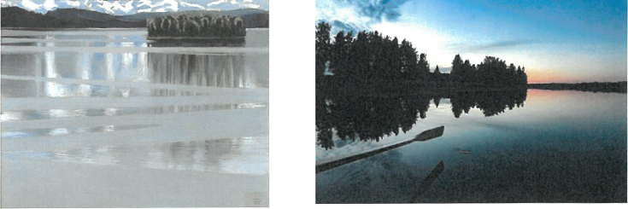

Frequently Asked Questions
Education

What is the duration of preparatory education?
  - The duration of preparatory education is usually 1 year. It can take longer, depending on the pupil and their language skills. Preparatory education teachers arrange regular meetings with the pupil and their guardian where they review the pupil’s skill levels and possible special needs.

Why preparatory education doesn’t include the pupil’s native language lessons?
  - The purpose of preparatory education is to prepare the pupil for Finnish basic education. Therefore, the emphasis of education is on teaching Finnish to the pupil. The pupil’s cultural background and language are taken into consideration in the teaching. The pupil’s native language is seen as an important part of their identity and as a tool for learning new languages. When there are enough pupils who speak the same language, the school may arrange teaching in the pupils’ native language.

Do pupils need money during the school day, e.g., for food?
  - In Finland, school education is completely free. Pupils don’t need to have money at school, as the school takes care of the expenses. The school meal is free for all pupils. The food is balanced and in compliance with nutritional recommendations. Pupils’ allergies and possible food limitations are taken into consideration at school meals. If the school class goes on a school trip, pupils can bring a little cash with them.

